**Goal:** Create Custom Parsley Payout Process and remove existing process POEXTRPRVN from user selection.

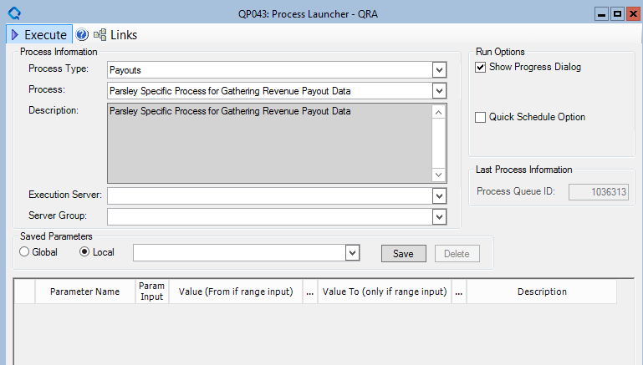

*\*No parameters will need to be inputted by the user to launch this process*

**Steps Need in Maintenance App**

1. Create process step “PARREVPO” that will call stored procedure “[PAR_SP_REVENUE_PAYOUT_PROCESS.”

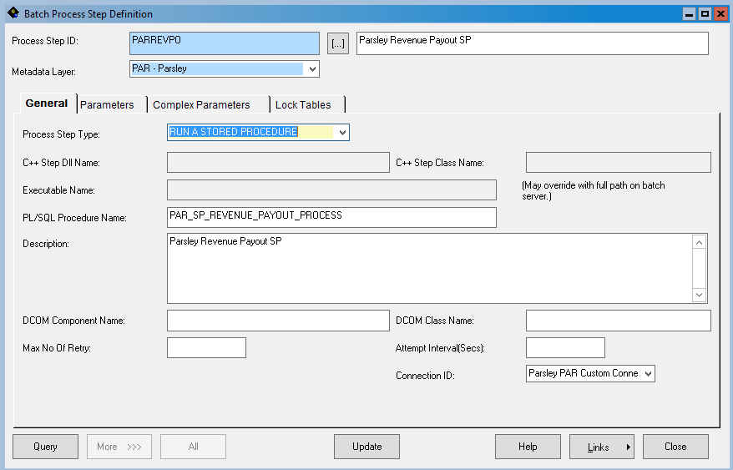

1. Create Main Process “PARREVPO”

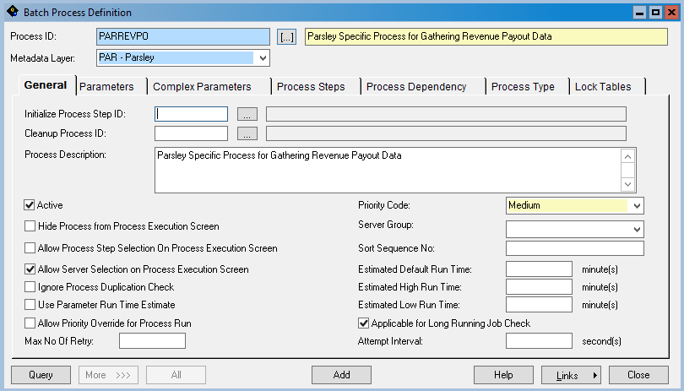

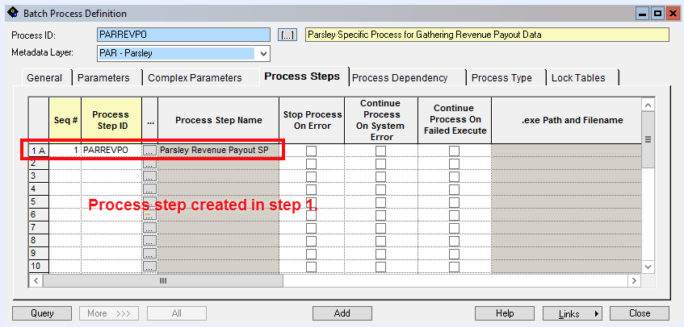

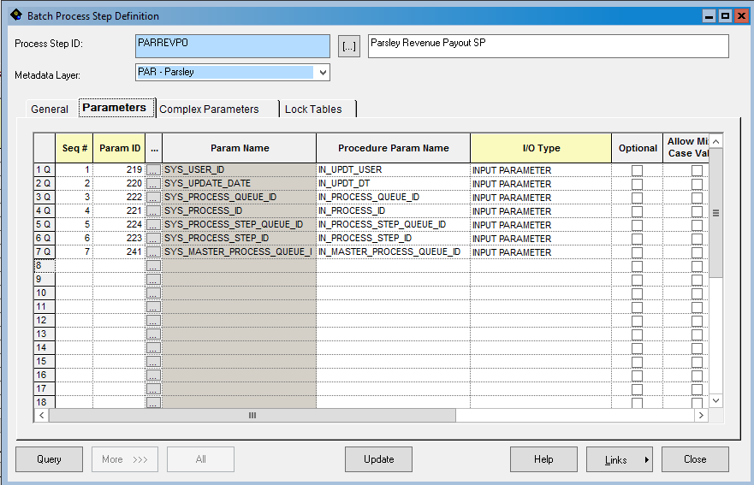

1. Add new process to “payout” process type. Remove old payout process from process type.

* Add “PARREVPO”
* Remove “POEXTRPRVN”

